UiPath SharePoint REST API v1 Activities

Author: Michael Conan

References:

* [Application setup](https://docs.microsoft.com/en-us/sharepoint/dev/solution-guidance/security-apponly-azureacs)
* [API Overview and operations](https://docs.microsoft.com/en-us/sharepoint/dev/sp-add-ins/get-to-know-the-sharepoint-rest-service?tabs=csom)

To setup the API activities for use, either run the interactive setup or follow the steps outlined below.

Manual Setup:

1. **Site Setup:** Create a SharePoint site or receive “owner” access to an existing site
2. **App Creation:** Navigate to {SharePoint Site URL}/_layouts/15/appregnew.aspx (app registration)
   1. Generate Client ID and Secret
   2. Name your app (Title)
   3. Add app domain as “localhost” and redirect URI as <https://localhost>/  
      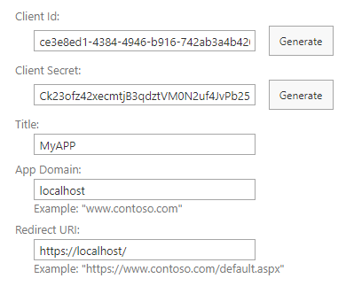
   4. Click ‘Create’
   5. Add Client ID and Secret as the username and password for a credential in Windows Credential Manager. Store the name of this credential in the Config.xlsx file.
3. **App Permissions:** Navigate to {SharePoint Site URL}/_layouts/15/appinv.aspx (app inventory)
   1. Enter the Client Id from step 2 and click “lookup”
   2. Under “Permission Request XML”, enter:  
      <AppPermissionRequests AllowAppOnlyPolicy="true">  
      <AppPermissionRequest Scope="http://sharepoint/content/sitecollection/web" Right="FullControl" />  
      </AppPermissionRequests>  
      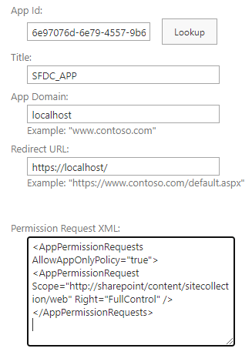
   3. Click ‘Create’

Using Activities:

1. Install Conan.SharePoint.Activities from Package Manager  
   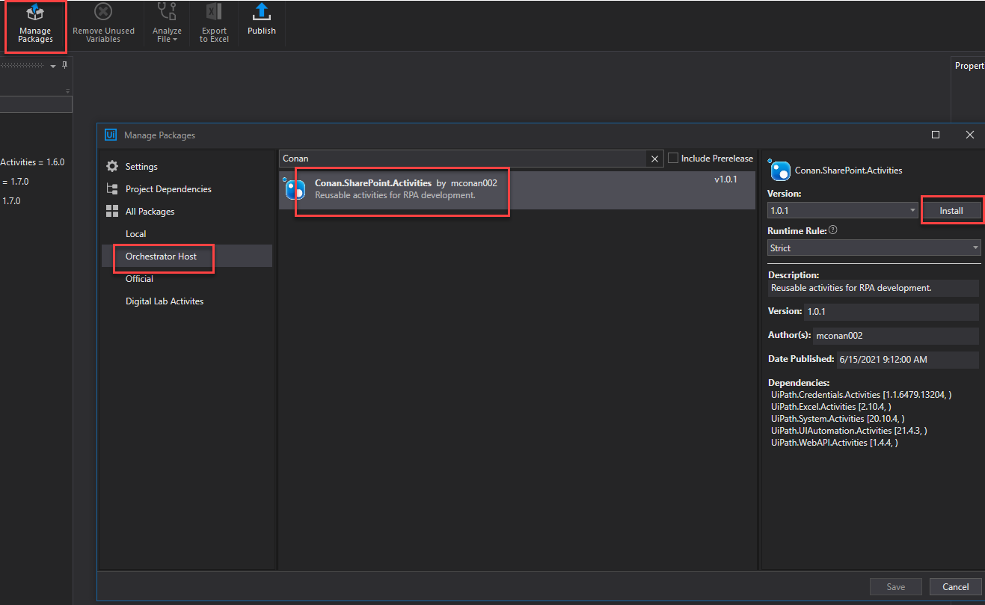
2. Add ‘Authorize_API’ activity to workflow, and input credentials and site URL (including trailing forward slash i.e. “https://pwc.sharepoint.com/sites/glcg25g9kt7pmchjvfq0/”)  
   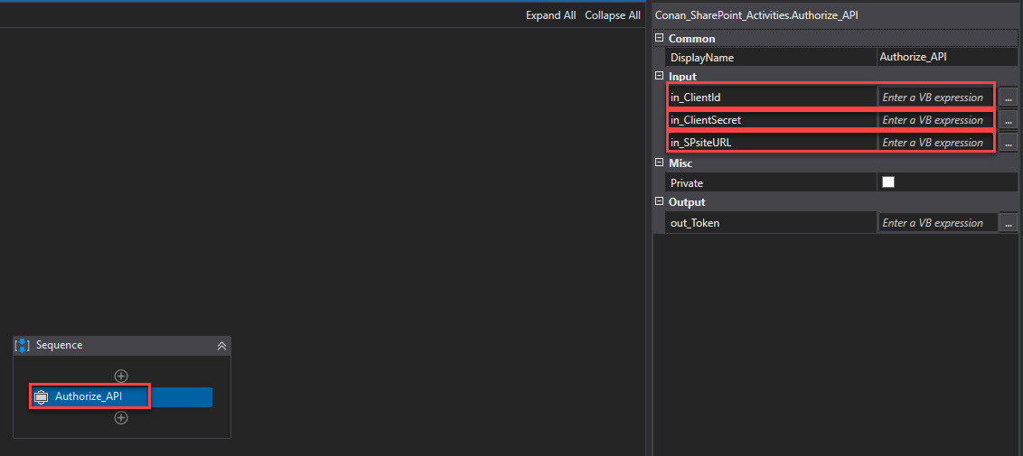
3. Assign token output from ‘Authorize_API’ to variable
4. Use token with other Library and List activities!